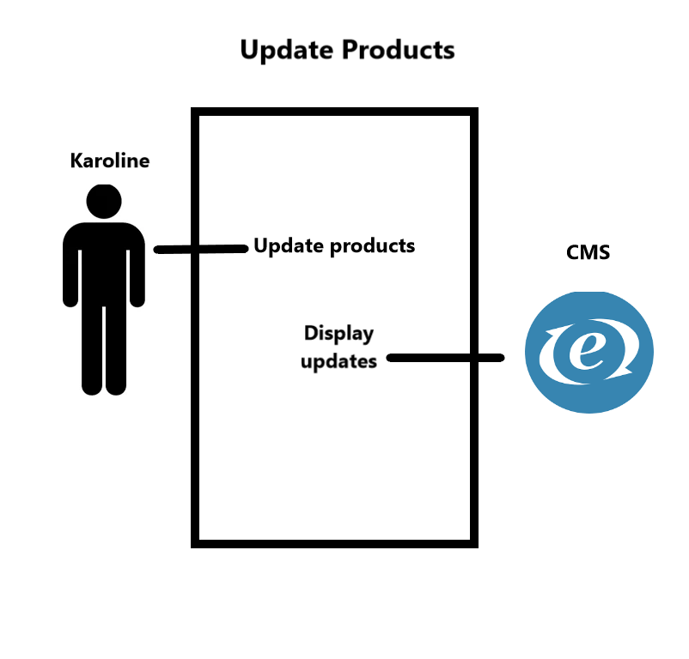

This diagram displays the process in which Karoline updates the products on her website through the use of a content management system to keep them up to date. The content management system displays the changes at the end of the process.